Call for Contributions

A Million Pictures:
History, Archiving, and Creative Re-use of Educational Magic Lantern Slides

Conference, 29 August 2017 – 1 September 2017, Utrecht, The Netherlands

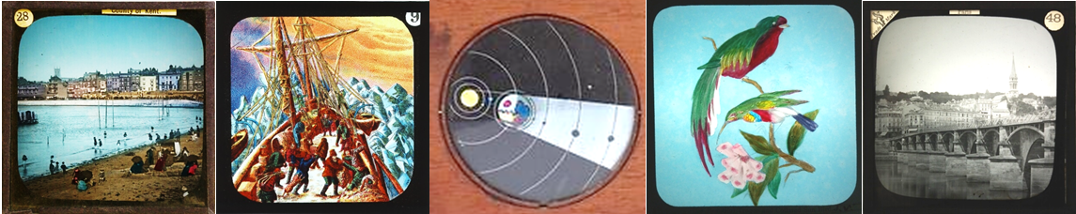

This conference is organised by the European Research Project A Million Pictures: Magic Lantern Slide Heritage as Artefacts in the Common European History of Learning .

The magic lantern was an important visual entertainment and means of instruction in nineteenth-century Europe and its former colonies; it was used in popular and academic teaching until the 1950s. However, despite its pervasiveness across multiple scientific, educational and popular contexts, magic lantern slides remain under-researched.
The project and the conference engage with magic lantern slides on several levels:
- studying the historical importance of magic lantern slides, projection apparatus, readings, and other paraphernalia as tools in the history of learning in a wide range of fields
- exchanging archival practices and discussing tools for cataloguing, archiving and giving access to magic lantern slides held in heritage institutions and other collections
- stimulating the re-use of this form of cultural heritage in scholarly, artistic, documentary, cultural and other creative practices.

The conference will present and discuss the outcomes of the Million Pictures project and share them with all those interested in the magic lantern and lantern slides from a scholarly, historical, archival, curatorial, artistic, museological, educational or practical point of view.
It will also provide a platform for both presenting ongoing scholarly research on the magic lantern, with an emphasis on lantern slides as a teaching tool as well as for presenting activities in the fields of archiving and creative re-use.

A keynote will be given by media historian Prof. Erkki Huhtamo (UCLA - Design Media Arts / Film, Television, and Digital Media) and a closing statement by Prof. Vanessa Toulmin (University of Sheffield / Research Director of the National Fairground Archive). The programme will also contain magic lantern performances, roundtables and demonstrations.

The conference invites scholars, practitioners in the heritage sector, in the creative industries, in the arts and in cultural/museum education to participate and submit a contribution.

We invite contributions in the following formats:

Scholarly Papers
We invite scholarly papers on the magic lantern and educational or non-fictional magic lantern slides that have a connection to the broad history of learning. These sessions will present ongoing or recently completed research by scholars from different fields such as Media History, Theatre and Performance Studies, History of Science, Cultural History, Word and Image Studies, Geography, and other disciplinary areas relevant to the lantern and slides.
Presentations should not exceed 20 minutes and will be followed by discussions.
Possible submissions can address (but are not limited to):
- Lantern slides and their role in various disciplinary histories
- Debates on teaching with lantern slides
- Performativity of lantern shows in scientific and other contexts
- Lantern slide lectures in local science, geography, natural history and other clubs and societies
- Science popularisers and the magic lantern
- Lantern use in regional, national or transnational contexts
- Production and distribution of lantern slides
- Circuits and tours of lantern slide lecturers and other performers
- Education of children and/or adults

Poster Presentations
We invite poster presentations on the wider topic of lantern slides in current research projects, (museological) education and established methods of giving access to this form of cultural heritage (digitization, documentation, public engagement) as well as wider aspects of lantern culture.

Demonstrations and Presentations of Artistic Forms of Engaging with Lantern Slides
We invite practitioners and performers to contribute documentations of artistic performances, to present film material, demonstrate a (digital) tool, or prepare another form of encounter or discussion. Please specify your topic/project and the form of presentation in your submission as well as specific requirements (room, technology, maximum number of participants). Contributions in either format do not have a minimum amount of time, but should not be longer than 20-30 minutes.

Input to Roundtable Discussions
We plan two roundtable discussions dedicated to the topics “Public activities with the Magic Lantern in archives and museums” and “Creative re-use of Magic Lantern slides”. We invite people with experience in these fields to give input to these roundtables.

5 Minutes of Experience Talks
Curators, collectors, practitioners, but also scholars are invited to prepare a five-minute presentation on their experiences obtained in or questions raised by a project concerning magic lantern slides which they would like to discuss with the specialists present during the conference. The 5 Minutes of Experience Talks will provide input for further discussion and should address the following questions: what was the aim of your project? How did you go about it? What was the result? What did you learn? What would you recommend?

Proposals for contributions in all forms should not exceed 5.000 characters and should be accompanied by a short bio (max. 1.000 characters).

Deadline for submissions is 31 January 2017.

Proposals for contributions should be submitted via the link on the conference page:
http://a-million-pictures.wp.hum.uu.nl/conference/

Acceptance will be announced in March 2017.

We are aware that not all potential participants are working at an institution that can cover their expenses. At the moment, we are applying for additional funding to offer fee waivers and, hopefully, part of the expenses.
Conference fees, including lunches and refreshments, will not exceed 20-25 Euro per day.

For questions, please contact Prof. Frank E. Kessler (f.e.kessler@uu.nl ) or Dr. Sarah Dellmann (s.dellmann@uu.nl).

